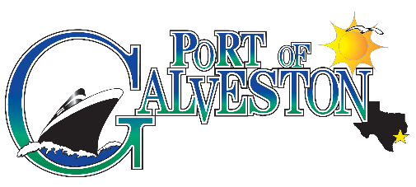
AAPA COMMUNICATIONS AWARDS PROGRAM

Port of Galveston
HURICANE HARVEY COMMUNICATIONS
Classification: Social/Web Based Media
Port Category: 2

SUMMARY: The U.S. Coast Guard captain of the Port of Galveston closed the ship channel to all inbound and outbound vessel traffic due to safety concerns. At the time there were 4 cruise ships in the Gulf of Mexico waiting to return to the Port of Galveston. In addition, passengers scheduled to embark on cruises leaving that week were arriving or had arrived in Galveston.

What are/were the entry’s specific communications challenges or opportunities?
Challenges were:
- Communicating that it was the US CG that had made the decision to shut down the ship channel due to safety concerns but that the Port of Galveston EOC remained open and that USCG were conducting search and rescue missions in the area.
- Communicating to cruise passengers (that were on one of the four ships out in the Gulf of Mexico) updates on the conditions of the ship channel (whisky, x-ray, zulu), the conditions of the Port of Galveston parking lots and parked cars and road conditions in the regional area.
- Communicating to future cruise passengers that were arriving or had arrived in Galveston to embark on a cruise of the condition of the ship channel, changes in cruise line itineraries, parking options, road conditions, hotel options and open gas stations.

How does the communication used in this entry complement the organization’s overall mission?
The Port’s Mission is elaborated as: “Port of Galveston management and staff will protect, preserve and enhance the assets of the City of Galveston’s waterfront property by continuing to rebuild and improve facilities to grow opportunities for existing customers and attract new businesses that will promote jobs and economic prosperity for the community.”

Although not mentioned in the mission statement, the Port of Galveston management and staff fully recognize the value of its employees and customers. Our priority was to focus on
their safety and provide accurate, timely information/updates to employees and customers via e mail, texts, website updates and social media.

What were the communications planning and programming components used for this entry?
- Established an Emergency Communication Center in coordination with the Port of Galveston Police Operations Center to communicate frequently with the City and County office of Emergency Management in addition to the cruise lines and USCG.
- Established a 24 hour call center to provide real time information regarding port conditions status, vessel traffic, road conditions, cruise line itinerary updates, parking information, available accommodations, and open gas stations.
- Updated all three social/web based media outlets, Twitter, Facebook and POG Website with real time updates on port conditions status, vessel traffic, road conditions, cruise line itinerary updates, parking information, available accommodations, and open gas stations.

What actions were taken and what communication outputs were employed in this entry?
The use of Twitter, Facebook and the Port of Galveston website module “Alert Center” on the homepage. All three outlets were linked and I used Facebook as the main platform.

What were the communications outcomes from this entry and what evaluation methods were used to assess them?
Analytics date range measured from the day we began communications regarding Tropical Storm Harvey on August 24 thru September 14, 2017. Total Posts:
Awareness: The volume, reach and exposure of the posts/tweets was in the thousands, most in double digit thousands and with one post reaching over a 104K.
Total reach: 1,291,853
Engagement: Participation including shares, comments, replies, and participation.
Total number of Engaged Users: 164,565
Total number of new Likes for date range: 5,138
Additionally, users wrote and shared complimentary posts about Port of Galveston communications during Hurricane Harvey related events including a mention in an article by Mark Orwoll in Conde Nast Traveler.
